Preventing severe asthma exacerbations in children: A randomised trial of mite impermeable bedcovers
Clare S Murray^{1,2} MD, Phil Foden¹ MSc, Helen Sumner¹ MPhil, Elizabeth Shepley^{1,3} PhD, Adnan Custovic⁴ MD PhD, and Angela Simpson¹ MD PhD
1. Division of Infection, Immunity and Respiratory Medicine, University of Manchester and University Hospital of South Manchester, Manchester Academic Health Sciences Centre, Manchester, United Kingdom.
2. Royal Manchester Children’s Hospital, Central Manchester University Hospitals NHS Foundation Trust, Oxford Road, Manchester, United Kingdom.
3. NIHR South Manchester Respiratory and Allergy Clinical Research Facility, University Hospital of South Manchester, United Kingdom
4. Department of Paediatrics, Imperial College London, United Kingdom.

Corresponding Author: Dr Clare S Murray
Division of Infection, Immunity and Respiratory Medicine, University of Manchester,
2nd Floor, Education and Research Building,
University Hospital of South Manchester,
Southmoor Road,
Manchester, M23 9LT
United Kingdom.
Email: clare.murray@manchester.ac.uk
Telephone: 0044 161 291 5876

Author Contributions
Clare Murray and Angela Simpson had full access to all of the data in the study and take responsibility for the integrity of the data and the accuracy of the data analysis.
Study concept and design: Clare Murray, Angela Simpson, Adnan Custovic
Acquisition, analysis, or interpretation of data: Clare Murray, Angela Simpson, Adnan Custovic, Helen Sumner, Phil Foden, Elizabeth Shepley
Drafting of the manuscript: Clare Murray, Angela Simpson
Critical revision of the manuscript for important intellectual content: Clare Murray, Angela Simpson, Adnan Custovic, Helen Sumner, Phil Foden, Elizabeth Shepley
Statistical analysis: Phil Foden
Obtained funding: Clare Murray, Angela Simpson, Adnan Custovic
Administrative, technical, or material support: Helen Sumner, Elizabeth Shepley
Study supervision: Clare Murray, Angela Simpson

Funding/Support
The study was funded by The JP Moulton Charitable Foundation. Infrastructure support was provided by the North West Lung Centre Charity. Neither the funders, nor sponsors of the study, nor the manufacturers from whom the encasings were purchased had any role in the study design, data collection, data analysis, data interpretation or writing of the report.

Descriptor number
14.1 Clinical studies: Asthma

Manuscript word count: 3408

At a glance commentary
Scientific knowledge on the Subject: Asthma exacerbations in children are a leading cause of hospitalisation. Exposure in sensitised individuals in synergy with viral infections greatly increases hospital admission risk. In the developed world house dust mite is the commonest sensitising allergen. Studies to date have not investigated the effect of allergen avoidance on asthma exacerbations and hospital admissions in children.
What this study adds to the field: The use of mite impermeable bedding in mite sensitised asthmatic children can significantly reduce the risk of severe exacerbations resulting in emergency hospital attendance.

This article has an online data supplement, which is accessible from this issue's table of content online at www.atsjournals.org

ABSTRACT
Rationale: Allergen exposure in sensitised asthmatics interacts with viruses in increasing the risk of asthma exacerbation.
Objectives: To evaluate the use of house dust mite impermeable bedding on severe asthma exacerbations in children.
Methods: We randomized mite-sensitised asthmatic children (3-17 years), following an emergency hospital attendance with an asthma exacerbation, to receive mite-impermeable (Active) or control (Placebo) bed encasings.
Measurements and main results: Over a 12-month intervention period the occurrence of severe asthma exacerbations were investigated. Of 434 asthmatic children who consented, 286 (mean age 7.7 years, 65.8% male) were mite sensitised and 284 were randomised (146 Active; 138 Placebo). At 12 months, significantly fewer children in the Active group had attended hospital with an exacerbation compared to the Placebo group (36/123 [29.3%] versus 49/118 [41.5%], p=0.047). In the multivariable analysis, the risk of emergency hospital attendance was 45% lower in the Active group (Hazard Ratio 0.55 [95%CI, 0.36-0.85], p=0.006) compared with the Placebo group. The annual rate of emergency hospital attendance with exacerbations was 27% lower in the Active compared with the Placebo group, but this did not reach significance (Estimated marginal mean [95% CI]: Active 0.38 [0.26-0.56] vs Placebo 0.52 [0.35-0.76], p=0.18). No difference between the groups in the risk of prednisolone use for exacerbation was found (Hazard Ratio 0.82 [0.58-1.17], p=0.28).
Conclusions: Mite-impermeable encasings are effective in reducing the number of mite sensitised asthmatic children attending hospital with asthma exacerbations, but not the number requiring oral prednisolone. This simple measure may reduce the health care burden of asthma exacerbations in children.

Abstract word count: 250 words
Trial registration: ISRCTN registry – 69543196; www.isrctn.com
Key words: Asthma, Exacerbations, Allergens, Dermatophagoides, Avoidance, Child
INTRODUCTION
Asthma is the most common chronic disease in childhood. Although most children with asthma are well-controlled on pharmacotherapies, a significant number experience exacerbations which remain one of the commonest reasons for paediatric hospital admission in the developed world (1). This unscheduled care accounts for a large proportion of asthma costs, and a single exacerbation can increase annual costs more than 3-fold (2). Previous hospital admissions predict future hospitalizations (3). Respiratory virus infections are major risk factors for hospital admission (4-6), particularly amongst children who are exposed to allergens to which they are sensitised, where these factors act synergistically to markedly increase the risk of hospital admission (7, 8). However, disrupting this interaction in atopic asthmatics is challenging.
There are currently no available vaccines for viruses which cause the majority of exacerbations. Allergen-specific immunotherapy is generally not recommended for patients with uncontrolled asthma (9). Anti-IgE monoclonal antibody (omalizumab) can reduce asthma exacerbations, but its use is limited to the most severe cases of asthma because of high cost and requirement for regular injections (10). Avoidance of allergen remains a potentially cost-effective intervention. However, no studies to date have investigated the effect of allergen avoidance on asthma exacerbations and hospital admissions, instead focussing on symptom scores, medication usage and lung function.
House dust mite (HDM) is a common allergen linked to expression of asthma, with ~65% of UK asthmatic children demonstrating sensitisation (7). Although high HDM exposure has been linked to asthma severity (11), a meta-analysis of 44 trials of mite avoidance was unable to demonstrate any clinical benefit of measures designed to reduce mite exposure, and concluded that mite control measures could not be recommended for asthma (12). However, this meta-analysis included many studies where no exposure reduction was achieved, and did not distinguish between adult and paediatric studies. Indeed, most studies which suggest benefits of mite avoidance have been conducted in children (13-17). However, these studies were either small (13, 15, 17), used multifaceted interventions making blinding difficult (13, 17), targeted multiple allergens (14, 16), or were conducted in populations which have poor access to healthcare/medications (14, 16). Given the evidence of a synergism between viral infection and allergen exposure in increasing the risk of asthma exacerbations in sensitised individuals (7, 18), we hypothesized that effective reduction in mite exposure may reduce the risk of exacerbations in these patients.
In this double-blind study, Preventing asthma exacerbations by avoiding mite allergen (PAXAMA), we compared the effect of mite-impermeable bed covers to that of placebo covers in reducing the risk of severe asthma exacerbations in mite-sensitised asthmatic children, who had recently attended hospital with an asthma exacerbation. Some of the results of these studies have been previously reported in the form of an abstract (19).

METHODS
Study Design
This randomized, double-blind, placebo-controlled, parallel-group study of the effect of mite-impermeable bed covers on the risk of severe asthma exacerbations in mite-sensitised asthmatic children was conducted across 14 hospitals with acute pediatric secondary care services in North-West England. Children were recruited between November 2011 and May 2013 and were followed for 12 months. The protocol was approved by local research ethics committee (NRES Committee North-West/Lancaster, REC approval number 11/ NW/0262).
Study Participants
We screened children aged 3-17 years with physician-diagnosed asthma who had presented to hospital with an asthma exacerbation. Children were excluded if already using allergen-impermeable bedding, born prematurely (<36 weeks) or had another respiratory disease. Participants were skin-prick tested once their exacerbation had resolved, to HDM, cat, dog, pollen and other pet allergens if applicable (Stallergenes, Paris, France), and classed as sensitized if the weal diameter was at least 3mm greater than the negative control. Only children sensitised to HDM (+/- other allergens) were eligible for randomisation. Parents provided written informed consent and children assent.
Randomisation and Masking
Children were randomly assigned 1:1 to active or placebo encasings using a computer-based minimisation procedure by a researcher who was not otherwise involved in the study. Children were stratified for age (3-10 years; 11-17 years), household cigarette smoking, pet sensitisation/ownership and treatment level (GINA steps 1-2; >3; eMethods, Online Supplement) in a double-blind manner. To maintain blinding no other information on HDM avoidance was given. All participants received identical printed washing instructions for the supplied encasings (eMethods, Online Supplement). The active encasings (Astex Pristine, ACP solutions Ltd, Gloucestershire, UK) were selected because their mite-proof efficacy had been demonstrated previously (20). Placebo encasings (made from poly-cotton) were custom manufactured (Musbury Fabrics, Rossendale, UK), to match the active encasings (Figure E1). Neither encasings contained a label. If more than one child from a family were allocated to the study, the second child was enrolled in the same arm as the index child, to avoid potential unblinding. Researchers fitting covers and collecting dust samples for allergen analysis were not involved in follow-up.
Procedures
Children had their inhaler technique checked and corrected if necessary. Encasings were fitted to the pillow, mattress and duvet of the child’s bed. Other beds in the same room and beds in which participants spent >1 night per week were also encased.
Study Assessments
Baseline evaluation included questionnaires on demographics, past medical/family history, sleeping arrangements, pet exposure and medication use. Interviewers masked to the child’s group assignment conducted telephone interviews with the primary caregiver at one, four, eight and twelve months to collect data on exacerbations, unscheduled medical care and medication. Quality of life (QOL) was assessed using Pediatric Asthma Caregiver’s Quality of Life Questionnaire PACQLQ(21) completed by parents, mini Pediatric Asthma Quality of Life Questionnaire (PAQLQ)(22) completed by children age >7 years, and asthma control by Asthma Control Questionnaire (ACQ)(23) completed in children aged 6 years or over.
Mite allergen (Der p 1) was measured in vacuumed dust samples collected from the child’s mattress and lounge floor prior to fitting the encasings and at 12 months, using enzyme-linked immunosorbent assay (Indoor Biotechnologies, Cardiff, UK; eMethods, Online Supplement)
Outcome measures
The primary outcome was the occurrence of severe asthma exacerbations during the 12-month intervention period. We used ATS/ERS definition of severe exacerbations (24), including:
(A) A hospitalization or emergency department (ED) visit because of asthma, requiring systemic corticosteroids (OCS) – abbreviated to emergency hospital attendance;
(B) Use of OCS or an increase from a stable maintenance dose, for >3 days (includes all OCS courses whether associated with an emergency hospital attendance or not).
Secondary endpoints included change in controller treatment from baseline to 12 months, PACQLQ(21), mini PAQLQ(22) and ACQ(23) scores. Compliance and acceptability of intervention was recorded.
Statistical Methods
Power calculation
Data from UK General Practice Research Database (GPRD; www.gprd.com) estimated that children who had >1 course of OCS in the previous 12 months had a mean exacerbation rate of 1.5/year (variance 1.02). For 90% power to detect a 30% reduction in exacerbation rate during the 12-month intervention period, 114 children per group were required, at a two-sided significance level of 0.05. Assuming 20% lost during follow-up, we aimed to randomise 284 children.
Data Analysis
Baseline characteristics were compared between groups using t-tests, Mann-Whitney U and chi-squared tests as appropriate. Efficacy analysis was performed according to the intention-to-treat principle (per-protocol analysis in supplement). Outcomes were assessed between the groups using chi-squared tests and logistic regression for children who completed 12 months of follow-up. Cox regression analysis assessed time to first emergency hospital attendance and prednisolone usage, and included all evaluable data with censoring for those who did not complete 12 months follow-up. Negative binomial generalized linear models analysed count data for outcomes; results expressed as estimated marginal means (EMM) and 95% confidence intervals (CI) for annual rates/participant (25). Multivariable models were adjusted for age, gender, ethnic group, maintenance asthma treatment, hospitalisations in the 12-months prior to randomisation, index of multiple deprivation and tobacco smoke exposure. General linear models with repeated measures were used to compare mite allergen levels and prescribed treatments across time between the groups. Der p 1 levels were log_{e} transformed to normalise the data prior to analysis; results presented as geometric means (GM). The conventional two-sided 5% significance level was used.
Exploratory subgroup analyses (not pre-specified) were conducted based on age, GINA step, sensitisation status, exposure to smoking and socioeconomic status (eMethods in Supplement) (26).
Analyses were carried out using SPSS 22 (IBM, New York, USA) and Stata 13 (StataCorp, Texas, USA).

RESULTS
Patients
From November 2011 to May 2013, 434 children were screened to take part in the study. Of those, 286 were HDM-sensitised and 284 underwent randomization (146 Active; 138 Placebo; Figure 1). Baseline characteristics and Der p 1 levels were similar in both groups (Table 1; Tables E1, E2). Twelve month follow-up was completed in 123 (84.2%) in the Active arm and 118 (85.5%) in the Placebo arm; overall, 208 children (73.2%) reported full compliance throughout the study (Per-protocol analysis).
Primary outcome
A) Hospitalization or ED visit because of asthma requiring systemic corticosteroids
Significantly fewer children in the Active group attended hospital with one or more severe asthma exacerbations compared to the Placebo group (36/123 [29.3%] versus 49/118 [41.5%]; OR 0.58 (0.34, 0.99), p=0.047; Figure 2A).
Time to first exacerbation requiring emergency hospital attendance was significantly longer in the Active group (p=0.041), and the risk of emergency hospital attendance was 45% lower in the Active group (Hazard ratio (HR) 0.55 [0.36-0.85], p=0.006), compared with the Placebo group (Figure 3; Table E3, multivariable model, adjusted for age, gender, GINA step, ethnicity, deprivation score and tobacco smoke exposure). Although, the annual rate of emergency hospital attendance was 27% lower in the Active compared with the Placebo group, this did not reach significance (EMM [95% CI]: Active 0.38 [0.26-0.56] vs Placebo 0.52 [0.35-0.76], p=0.18). The distribution of the numbers of attendances did not differ between the groups (p=0.5; FigureE2).
Per protocol analysis is presented in the Online Supplement (Figures E3-E6); the risk of emergency hospital attendance was 54% lower in the Active group compared to the Placebo group (HR 0.46 [0.28-0.76]; p=0.002).
B) Use of oral corticosteroids for >3 days
There was no difference in the numbers of children who received a course of OCS for an asthma exacerbation (whether associated with an unscheduled hospital or general practitioner attendance or by a home rescue pack) between the groups (Active 48.8% vs Placebo 50.0%, p=0.85, Figure 2B).
Investigating the time to first OCS use, there was no difference between groups in the univariable analysis (p=0.67) or in the multivariable model (HR 0.82 [0.58-1.17], p=0.28). The annual rate of OCS courses prescribed was not different between the groups (EMM [95% CI]; Active: 0.77 [0.55-1.06] vs Placebo: 0.85 [0.62-1.16], p=0.57). Per protocol analysis is presented in the Online Supplement (Figure E3b).
Secondary Outcomes
Mean values for PACQLQ and ACQ at each time are presented in Table E4 in the online supplement. Parents of children in both groups reported significantly improved PACQLQ between one and 12 months (mean difference [95% CI]; Active: 0.50 points [0.14-0.8], p=0.007; Placebo: 0.57 points [0.12-1.02], p=0.01), with no difference between the groups. Although significant improvement in ACQ score over time was observed only in Active children (-0.56 points, [-0.18,-0.93], p=0.004), and not in those with Placebo covers (-0.25 points, [-0.61, 0.11], p=0.16), there was no difference between the groups.
There was no difference in GINA step between the two groups at baseline (Table1, Table E1). At the end of the intervention period, GINA step had been increased in 10.7% of the Active group and 14.5% of Placebo group (p=0.37). Children who had any exacerbations during follow-up were more likely to have their GINA step increased by the end of follow-up compared to children who did not suffer an exacerbation (27.1% vs 4.5% respectively, p<0.001), irrespective of group allocation.
Children in the active group were more likely to complain about the encasings (Table E5). Despite this, the number adhering to the intervention at 12 months was similar in both groups (101 Active, 107 Placebo, p=0.11). Amongst all those fully compliant with the bedding almost 90% reported they would continue to use the encasings after the study.
Mite Allergen levels
Der p 1 levels in dust from the child’s mattress was reduced by 84% in the Active group following the intervention, with no change in the Placebo group (p<0.001; Figure 4). Der p 1 in the lounge floor was unchanged in both groups (p=0.48; Figure E7).
Post-hoc analyses
In a multivariable Cox regression analysis (Table E6) a reduction in risk of an emergency hospital attendance was seen for children in the Active group aged 3-10 years (HR 0.54 [0.33-0.87], p=0.01, Figure E8), in those sensitised only to mite (p=0.04), in those from non-smoking homes (p=0.02), in those on GINA treatment step >3 (p=0.03) and in those from the most deprived homes (p=0.01). None of the interaction terms were significant however. Also, in younger children (3-10years), a non-significant reduction in risk of OCS use was seen in those in the Active group (HR 0.69 [0.46-1.04], p=0.08, Figure E9).

Discussion
In our study of HDM allergic children who had recently suffered a severe asthma exacerbation, the risk of further severe asthma exacerbations requiring an emergency hospital attendance was reduced by 45% in those who had mite-impermeable encasings fitted to the mattress, pillow and duvet. This is the first study of the effect of such an intervention on exacerbations in children. The annual rate of emergency hospital attendance, though 27% lower in the active compared to the placebo group, was not significantly reduced (p=0.18). There was no difference in the proportion of children requiring courses of oral steroids for asthma exacerbations. The encasings were highly effective in reducing recoverable mite allergen.
Asthma exacerbations have been ranked highly by clinicians and parents as important outcomes for clinical trials in children (27). Although comparatively rare events, severe asthma exacerbations result in many hospital admissions which are particularly costly, emphasizing the relevance of this as an outcome (28). Using real data from UK GPRD to power the study, we estimated that the exacerbation rate would be 1.5/annum for children who had suffered an exacerbation in the previous year. As previous hospitalizations/exacerbations are amongst the best predictors of future risk (3,29), we recruited children when attending hospital with an exacerbation. However, our observed exacerbation rate during follow-up was materially lower (Placebo group: 0.85 oral corticosteroid courses/annum), reducing our power to detect significant differences between the groups. That we were able to detect a statistically significant difference between groups for numbers of children requiring hospital attendances for asthma exacerbations reflects the large effect size seen.
Although the number of children who experienced any emergency hospital attendance with an asthma exacerbation was significantly reduced following the active intervention, some children continued to have hospital attendances, a few of them having multiple attendances. However, the distribution of multiple attendances did not differ between treatment groups.
As with many treatments for asthma (e.g. long acting Beta-agonists, leukotriene receptor antagonists), it is clear that some individuals respond to the treatment and others do not (30), but predicting those who will respond is challenging. Although our trial was not powered to carry out subgroup analyses, we performed exploratory analyses in an attempt to identify the characteristics of the children who showed the best response; this indicated that younger children, those sensitised only to mite, those with more severe disease (GINA 3+) and those not exposed to smoking had fewer emergency hospital attendances. Similar subgroup analyses in those requiring OCS courses for asthma exacerbations also suggested that younger children may be more likely to respond to this intervention. Whilst recognising that the subgroup analysis is exploratory, we propose that allergen avoidance may be more effective in younger children, in whom the disease may have been present for a shorter time. This may be analogous to occupational asthma, where removal of allergen exposure is effective if done soon after the onset of disease (31), and may explain the differences between our results compared to large studies in adults (32). In addition, younger children may spend a higher proportion of time in bed, making this dust reservoir a potentially larger contributor to personal mite exposure than in older children or adults. Recent reports in adults suggested that mite exposure may be higher during the daytime, and may reflect lifestyle and clothing worn (33). We speculate that personal allergen exposure is different in young children, who generally wear clothes that can be hot washed, and undertake different activities. We have no evidence that the younger children were more compliant with the intervention.
Despite the risk of emergency hospital attendance being reduced in the Active group, the risk of receiving OCS was not significantly reduced, although a trend was seen in younger children. A small number of OCS courses were administered by parents using home rescue packs without contemporaneous medical direction (eight, three day courses, in total in 6 children), some of which may have been unnecessary. Unfortunately we were unable to assess children to confirm the presence of an exacerbation; care was provided by their family doctor or by urgent care services as the parents saw appropriate. It may be that the study intervention genuinely reduced the severity of exacerbations resulting in fewer hospital attendances, but not fewer courses of OCS.
Many factors influence consulting behaviours in parents with sick children; our recruitment strategy may have selected those more likely to present to hospital. Indeed, in our population, the majority of exacerbations resulted in an emergency hospital attendance (~70%). It is likely however, that those exacerbations requiring an emergency hospital attendance were more severe and regardless are certainly more expensive to the provider, and so we believe that the reduction seen is of clinical importance.
In order to establish that the reduction in exacerbations seen was not due to changes in controller medication we examined changes in prescribed medication during follow-up and found no difference between the groups. All treatments were prescribed by the participants’ usual physicians who were blind to the treatment allocation and not influenced by the study team.
As there is no QOL score for asthma sufferers or caregivers validated for use in children under seven years, we used the PACQLQ for all participants (recognising that this has limitations), and the mini PAQLQ for children over seven years. There were no between-group differences in quality of life (both tending to show within-group improvements). Interestingly, despite recent exacerbations, both groups reported good QOL and control at baseline, leaving little prospect of demonstrating significant between group differences.
Children who were in the Active group complained more about the bedding than those using the placebo covers. It is possible that this difference in perception led to unblinding of individuals (i.e. believing that they must have the real covers because they are uncomfortable). However, we believe this is unlikely to have affected the results of the study given the objective nature of our outcomes. It is important to note that compliance with the covers was not significantly different between the groups, and adherence (>70%) appeared to be at least as good, if not better than, with medications usually prescribed for asthma (e.g. inhaled corticosteroids ~50% (34)).
There are some other limitations to our study. All data on exacerbations and OCS use was reported by parents/carers and not confirmed by their primary care physician. However, we gathered information from parents on a 3 monthly basis and therefore recall should not be a significant issue and we would expect any bias to be similar across the groups. We were unable to measure adherence to prescribed treatment within this study, and although it is unlikely that one arm was more adherent than the other, we cannot exclude this from having occurred. Evidence from previous studies suggest that viruses and allergens in sensitised individuals act synergistically to increase the risk of asthma exacerbation and hospitalisation. As we have no information on the trigger for individual exacerbations (viral or otherwise) we were unable to perform an analysis to identify whether the effectiveness of the intervention was dependent upon the trigger.

CONCLUSIONS
We found that the simple and relatively cheap intervention of mite allergen impermeable bed encasings, costing around £130/US $200, is effective in reducing emergency hospital attendance with severe asthma exacerbations. In the population we have studied we estimate that approximately 8 children would need to be treated in order to prevent one child having any hospital attendances in the following year. It is likely that there is a subgroup of children in whom the intervention is more beneficial and although our subgroup analysis would suggest this might be younger, mono-sensitised children in non-smoking households, further research is required to clarify this.

Acknowledgements
We would like to thank the children and their parents for their participation. We would like to thank Anna Duxbury for her assistance with recruitment and data collection and Mandy Mycock for the dust sample collection (both of whom received salaries from the grant). We greatly appreciate Sarah Rickard and the team from the NIHR Greater Manchester, Lancashire and Cumbria Medicines for Children Research Network who assisted with recruitment across the region. We thank Lesley Oldham for assistance with the database and its management. We thank Drs Simon Stephan and the NIHR South Manchester Respiratory and Allergy Clinical Research Facility for assistance with laboratory work. We thank Hazera Begum for collecting user feedback. We would also like to thank the PAXAMA principal investigators: Dr Shirley Castille, Dr Chris Cooper, Dr Sharryn Gardner, Dr Susan Glass, Dr Kate Goldberg, Dr Prakash Kamath, Ms Amy Lamb, Dr David Levy, Dr Naveen Rao, Dr Tanya Robertson and Dr Karnam Sugumar. None of these individuals received additional funding for their contributions. We much appreciate the support of the North West Lung Centre Charity for infrastructure support. The study was funded by The JP Moulton Charitable Foundation.

Conflicts of Interest Disclosures
Dr Murray has received grants from NIHR, JP Moulton Charitable Foundation and from North West Lung Research Centre Charity. She has received lecture fees from GSK and Novartis and travel grants from Novartis. Professor Custovic has received grants from Medical Research Council, JP Moulton Charitable Foundation and from North West Lung Research Centre Charity. He receives personal fees from AstraZeneca, Novartis, ThermoFisher and Regeneron / Sanofi. Professor Simpson has received grants from Medical Research Council, NIHR and EU FP7. She has received lecture fees from GSK, Chiesi and Thermofisher Scientific. Philip Foden, Helen Sumner and Elizabeth Shepley have no conflicts of interest.

REFERENCES
1. Hasegawa K, Bittner JC, Nonas SA, Stoll SJ, Watase T, Gabriel S, Herrera V, Camargo CA, Jr., Multicenter Airway Research Collaboration I. Children and Adults With Frequent Hospitalizations for Asthma Exacerbation, 2012-2013: A Multicenter Observational Study. The journal of allergy and clinical immunology In practice 2015.
2. Lane S, Molina J, Plusa T. An international observational prospective study to determine the cost of asthma exacerbations (COAX). Respir Med 2006; 100: 434-450.
3. Schatz M, Cook EF, Joshua A, Petitti D. Risk factors for asthma hospitalizations in a managed care organization: development of a clinical prediction rule. Am J Manag Care 2003; 9: 538-547.
4. Johnston SL, Pattemore PK, Sanderson G, Smith S, Lampe F, Josephs L, Symington P, O'Toole S, Myint SH, Tyrrell DA, et al. Community study of role of viral infections in exacerbations of asthma in 9-11 year old children. BMJ 1995; 310: 1225-1229.
5. Heymann PW, Platts-Mills TA, Johnston SL. Role of viral infections, atopy and antiviral immunity in the etiology of wheezing exacerbations among children and young adults. Pediatr Infect Dis J 2005; 24: S217-222, discussion S220-211.
6. Cox DW, Bizzintino J, Ferrari G, Khoo SK, Zhang G, Whelan S, Lee WM, Bochkov YA, Geelhoed GC, Goldblatt J, Gern JE, Laing IA, Le Souef PN. Human rhinovirus species C infection in young children with acute wheeze is associated with increased acute respiratory hospital admissions. Am J Respir Crit Care Med 2013; 188: 1358-1364.
7. Murray CS, Poletti G, Kebadze T, Morris J, Woodcock A, Johnston SL, Custovic A. Study of modifiable risk factors for asthma exacerbations: virus infection and allergen exposure increase the risk of asthma hospital admissions in children. Thorax 2006; 61: 376-382.
8. Soto-Quiros M, Avila L, Platts-Mills TA, Hunt JF, Erdman DD, Carper H, Murphy DD, Odio S, James HR, Patrie JT, Hunt W, O'Rourke AK, Davis MD, Steinke JW, Lu X, Kennedy J, Heymann PW. High titers of IgE antibody to dust mite allergen and risk for wheezing among asthmatic children infected with rhinovirus. The Journal of allergy and clinical immunology 2012; 129: 1499-1505 e1495.
9. http://www.ginasthma.org/documents/4. GINA Report, Global strategy for asthma management and prevention. 2015.
10. [TA278] NTag. Omalizumab for treating severe persistent allergic asthma. Nice Technology appraisal guidance [TA278]. https://www.nice.org.uk/guidance/TA278. 2013.
11. Custovic A, Simpson A. The role of inhalant allergens in allergic airways disease. Journal of investigational allergology & clinical immunology 2012; 22: 393-401; qiuz follow 401.
12. Gotzsche PC, Johansen HK. House dust mite control measures for asthma. The Cochrane database of systematic reviews 2008: CD001187.
13. Carswell F, Birmingham K, Oliver J, Crewes A, Weeks J. The respiratory effects of reduction of mite allergen in the bedrooms of asthmatic children--a double-blind controlled trial. Clinical and experimental allergy : journal of the British Society for Allergy and Clinical Immunology 1996; 26: 386-396.
14. Carter MC, Perzanowski MS, Raymond A, Platts-Mills TA. Home intervention in the treatment of asthma among inner-city children. The Journal of allergy and clinical immunology 2001; 108: 732-737.
15. Halken S, Host A, Niklassen U, Hansen LG, Nielsen F, Pedersen S, Osterballe O, Veggerby C, Poulsen LK. Effect of mattress and pillow encasings on children with asthma and house dust mite allergy. The Journal of allergy and clinical immunology 2003; 111: 169-176.
16. Morgan WJ, Crain EF, Gruchalla RS, O'Connor GT, Kattan M, Evans R, 3rd, Stout J, Malindzak G, Smartt E, Plaut M, Walter M, Vaughn B, Mitchell H. Results of a home-based environmental intervention among urban children with asthma. N Engl J Med 2004; 351: 1068-1080.
17. Shapiro GG, Wighton TG, Chinn T, Zuckrman J, Eliassen AH, Picciano JF, Platts-Mills TA. House dust mite avoidance for children with asthma in homes of low-income families. The Journal of allergy and clinical immunology 1999; 103: 1069-1074.
18. Green RM, Custovic A, Sanderson G, Hunter J, Johnston SL, Woodcock A. Synergism between allergens and viruses and risk of hospital admission with asthma: case-control study. BMJ 2002; 324: 763.
19. Murray C.S, Sumner H, Mycock M, Duxbury A, Custovic A, Simpson A. Preventing asthma exacerbations by allergen-impermeable bed covers in children: Double-blind randomised placebo controlled trial. Allergy 2015; 70 (S101): 75
20. Vaughan JW, McLaughlin TE, Perzanowski MS, Platts-Mills TA. Evaluation of materials used for bedding encasement: effect of pore size in blocking cat and dust mite allergen. J Allergy Clin Immunol 1999; 103(2 Pt 1):227-31.
21. Juniper EF, Guyatt GH, Feeny DH, Ferrie PJ, Griffith LE, Townsend M. Measuring quality of life in the parents of children with asthma. Quality of life research : an international journal of quality of life aspects of treatment, care and rehabilitation 1996; 5: 27-34.
22. Juniper EF, Guyatt GH, Feeny DH, Ferrie PJ, Griffith LE, Townsend M. Measuring quality of life in children with asthma. Quality of life research : an international journal of quality of life aspects of treatment, care and rehabilitation 1996; 5: 35-46.
23. Juniper EF, Gruffydd-Jones K, Ward S, Svensson K. Asthma Control Questionnaire in children: validation, measurement properties, interpretation. The European respiratory journal 2010; 36: 1410-1416.
24. Reddel HK, Taylor DR, Bateman ED, Boulet LP, Boushey HA, Busse WW, Casale TB, Chanez P, Enright PL, Gibson PG, de Jongste JC, Kerstjens HA, Lazarus SC, Levy ML, O'Byrne PM, Partridge MR, Pavord ID, Sears MR, Sterk PJ, Stoloff SW, Sullivan SD, Szefler SJ, Thomas MD, Wenzel SE, American Thoracic Society/European Respiratory Society Task Force on Asthma C, Exacerbations. An official American Thoracic Society/European Respiratory Society statement: asthma control and exacerbations: standardizing endpoints for clinical asthma trials and clinical practice. Am J Respir Crit Care Med 2009; 180: 59-99.
25. Fuhlbrigge A, Peden D, Apter AJ, Boushey HA, Camargo CA, Jr., Gern J, Heymann PW, Martinez FD, Mauger D, Teague WG, Blaisdell C. Asthma outcomes: exacerbations. The Journal of allergy and clinical immunology 2012; 129: S34-48.
26. Wang R, Lagakos SW, Ware JH, Hunter DJ, Drazen JM. Statistics in medicine--reporting of subgroup analyses in clinical trials. N Engl J Med 2007; 357: 2189-2194.
27. Sinha IP, Gallagher R, Williamson PR, Smyth RL. Development of a core outcome set for clinical trials in childhood asthma: a survey of clinicians, parents, and young people. Trials 2012; 13: 103.
28. Asthma UK warns of alarming increase in hospital admissions for children. http://www.asthma.org.uk/Sites/healthcare-professionals/news/hcp-asthma-uk-warns-of-alarming-increase-in-hospital-admissions-for-children
29. Pollack CV, Jr., Pollack ES, Baren JM, Smith SR, Woodruff PG, Clark S, Camargo CA. A prospective multicenter study of patient factors associated with hospital admission from the emergency department among children with acute asthma. Arch Pediatr Adolesc Med 2002; 156: 934-940.
30. Lemanske RF, Jr., Mauger DT, Sorkness CA, Jackson DJ, Boehmer SJ, Martinez FD, Strunk RC, Szefler SJ, Zeiger RS, Bacharier LB, Covar RA, Guilbert TW, Larsen G, Morgan WJ, Moss MH, Spahn JD, Taussig LM, Childhood Asthma R, Education Network of the National Heart L, Blood I. Step-up therapy for children with uncontrolled asthma receiving inhaled corticosteroids. N Engl J Med 2010; 362: 975-985.
31. Dykewicz MS. Occupational asthma: current concepts in pathogenesis, diagnosis, and management. The Journal of allergy and clinical immunology 2009; 123: 519-528; quiz 529-530.
32. Woodcock A, Forster L, Matthews E, Martin J, Letley L, Vickers M, Britton J, Strachan D, Howarth P, Altmann D, Frost C, Custovic A, Medical Research Council General Practice Research F. Control of exposure to mite allergen and allergen-impermeable bed covers for adults with asthma. N Engl J Med 2003; 349: 225-236.
33. Tovey ER, Willenborg CM, Crisafulli DA, Rimmer J, Marks GB. Most personal exposure to house dust mite aeroallergen occurs during the day. PloS one 2013; 8: e69900.
34. Morton RW, Everard ML, Elphick HE. Adherence in childhood asthma: the elephant in the room. Archives of disease in childhood 2014; 99: 949-953.

Figure Legends
Figure 1. CONSORT (Consolidated Standards of Reporting Trials) flow diagram showing the participants’ course during the study.

Figure 2. Proportion of children who suffered one or more severe exacerbation during the 12 month follow up period (for all children who completed 12 months Follow up, n=241). Results are shown for (A) one or more hospitalizations or ED visit requiring systemic corticosteroids because of an asthma exacerbation (p=0.047) and (B) the use of systemic corticosteroids for at least 3 days because of an asthma exacerbation (p=0.85).

Figure 3. Time to first hospitalizations or ED visit because of severe exacerbation of asthma. The model was adjusted for age, gender, ethnic group, maintenance asthma treatment, number of hospitalisations in the 12-month period prior to randomisation, index of multiple deprivation and tobacco smoke exposure. The risk was 45% lower in the Active compared with the placebo group (p=0.006).

Figure 4. Der p 1 levels in child’s mattress (ng/m²) at recruitment and 12 months after intervention. Results are shown as geometric mean and 95% confidence interval for Active covers (mite-impermeable) (dashed line) and Placebo covers (solid line).

Figure 1.
Unable to contact n=51
Received after recruitment had closed n=24
Referrals n=715

Telephone screened n=640
Declined n=104
Not eligible n=102 (20 not physician diagnosed asthma, 30 no recent exacerbation, 7 preterm, 15 using allergen bedding, 4 other diagnosis, 20 language barrier, 6 too young)
Randomised n=284
Placebo Covers n=138
(Der p 1 n= 134)
1 month F/U n=136
4 month F/U n=129
Lost to F/U n=7
Withdrawn n=0
Lost to F/U n=6
Withdrawn n=0
8 month F/U n=124
12 month F/U n=118
(Der p 1 n=106)

12 month F/U n=123
(Der p 1 n=108)

Active Covers
n =146
(Der p 1 n=137)
1 month F/U n=138
Lost to F/U n=2
Withdrawn n=0
4 month F/U n=136
Lost to F/U n=7
Withdrawn n=0
8 month F/U n=130
Consented n=434

HDM SPT +ve n=286 (n=2 uncertainty about sleeping arrangements, not randomised)
HDM SPT –ve n=148
Lost to F/U n=5
Withdrawn n=1
(wanted active bedding)
Lost to F/U n=3
Withdrawn n=2
(1 too busy, 1 bedding hadn’t helped)
Lost to F/U n=4
Withdrawn n=4
(3 bedding uncomfortable, 1 unknown)
Lost to F/U n=1
Withdrawn n=1
(wanted active bedding)
Figure 2
A.
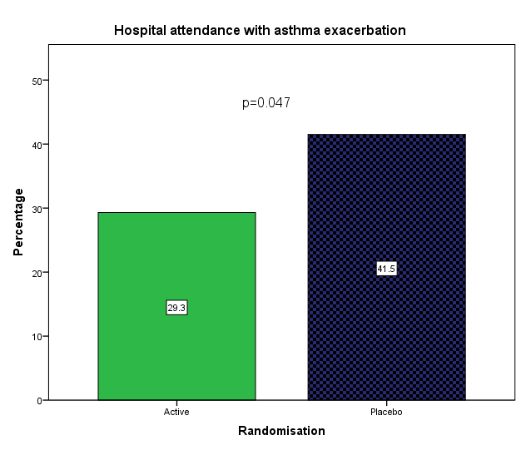

B.

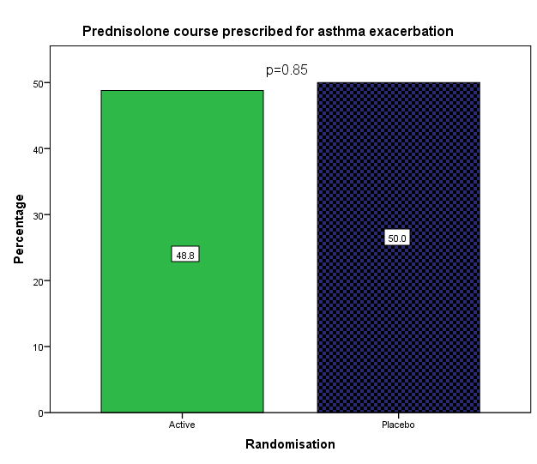

Figure 3.

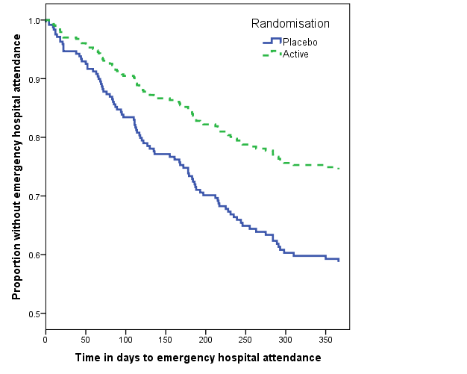
Number at risk
Placebo 136 119 105 94 89 77 71 70
Active 136 129 121 112 102 91 88 88
p=0.006

Figure 4.
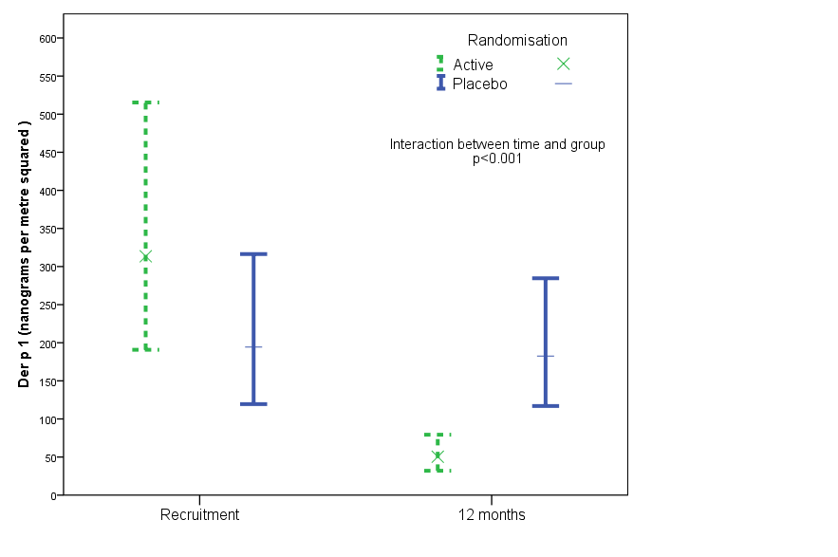

Table 1. Characteristics of study participants at randomisation.
*All children were skin test positive to house dust mite, but not all children completed skin test to other allergens. **Ascertained based on SPT or on symptom reports from parents and pet ownership/exposure.

 | Placebo covers | Mite-impermeable  Covers (Active) | P value
 | N=138 | N=146
Age (mean; SD) | 7.45 (3.55) | 7.11 (3.49) | 0.42
Age3-10 yrs | 106 (76.8%) | 117 (80.1%) | 0.50
Age 11-17 yrs | 32 (23.2%) | 29 (19.9%)
Gender; male | 94 (68.1%) | 93 (63.7%) | 0.43
Ethnicity |  | N=143 | 0.96
White | 89 (64.5%) | 91 (63.6%)
Asian | 35 (25.4%) | 36 (25.2%)
Other | 14 (10.1%) | 16 (11.2%)
Current hay fever | 41/134 (30.6%) | 46/129 (35.7%) | 0.38
Current eczema | 71 (51.8%) | 57/140 (40.7%) | 0.07
Food allergy | 26/130 (20.0%) | 40/138 (29.0%) | 0.09
Maternal asthma | 43 (31.2%) | 39/142 (27.5%) | 0.50
Paternal asthma | 30/134 (22.4%) | 40/142 (28.2%) | 0.27
Maternal smoking | 35 (25.4%) | 34/145 (23.4%) | 0.71
Paternal smoking | 31/133 (23.3%) | 43/141 (30.5%) | 0.18
Smoking by a household member | 57 (41.3%) | 67 (45.9%) | 0.44
Deprivation index (mean; SD) | 34.16 (19.34) | 34.74 (17.32) | 0.79
Sensitized to*
Mite | 138/138 (100%) | 146/146 (100%)
Table 1. Characteristics of study participants at randomisation (“Continued”)

Mite only | 50/125 (40%) | 60/130 (46.1%) | 0.28
Cat | 46/125 (36.8%) | 46/130 (35.4%) | 0.81
Dog | 45/125 (36.0%) | 44/130 (33.8%) | 0.72
Grass | 49/129 (38.0%) | 46/136 (33.8%) | 0.48
Aspergillus | 8/126 (6.3%) | 3/136 (2.2%) | 0.09
Tree pollen | 7/125 (5.6%) | 4/135 (3.0%) | 0.29
Number of allergens sensitised to excluding HDM (median; IQR) | N=131  1 (0-2) | N=135  1 (0-2) | 0.55
Pet contact | 58/137 (42.3%) | 64/145 (44.1%) | 0.76
Cat owner | 22/137 (16.1%) | 21/145 (14.5%) | 0.71
Dog owner | 31/137 (22.6%) | 36/145 (24.8%) | 0.66
Sensitised and exposed to pet** | 29 (21.0%) | 31 (21.2%) | 0.96
GINA Step |  |  | 0.98
GINA step 1-2 | 72 (52.2%) | 76 (52.1%)
GINA step > 3 | 66 (47.8%) | 70 (47.9%)

