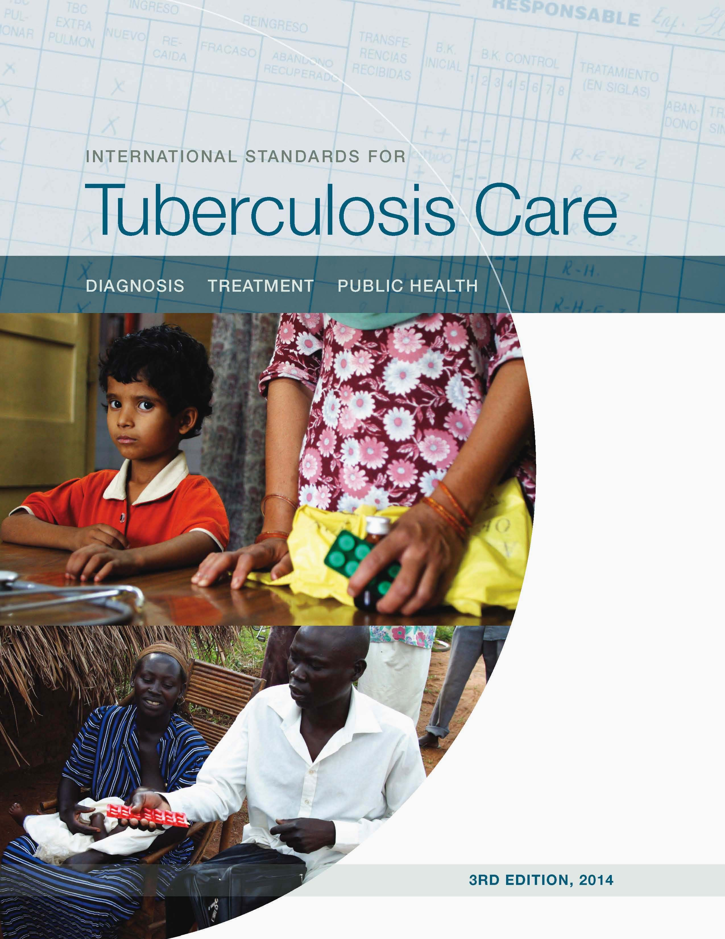

[www.walimu.org/istc](http://www.walimu.org/istc)



*International Standards for Tuberculosis Care*

*Edition 3, 2014*

mobile app with clinical algorithms

The International Standards for Tuberculosis Care (*ISTC*) mobile app provides quick access to essential information and best practices for managing TB.  Through the app, physicians can access specialized algorithms based on the *ISTC* that provide step by step guidance for diagnosing and managing TB patients. The app also comes with the twenty-one standards form the *ISTC* for effective care of TB patients in line with international standards, and easy access to useful information, such as dosing tables and guidance on drug interactions.  Clinical decision algorithms provide physicians with guidance on all the necessary steps to manage a TB patient, including evaluating for TB, diagnosing sputum-smear negative TB, treating patients, managing drug-resistance, and evaluating children and patients who are HIV positive.

The *International Standards for Tuberculosis C*are edition 3, available at [www.ISTCweb.org](http://www.ISTCweb.org)

describes a widely accepted level of care that all practitioners, both public and private, should seek to achieve in managing patients who have or may have tuberculosis.  This mobile version includes exclusive and interactive algorithms for the diagnosis and management of TB as well as all the content from the published guidelines. The *ISTC* is published by TB CARE I with funding by the United States Agency for International Development (USAID).  This app is developed by AgileMD and made possible by the American Thoracic Society.

Developed by





For more information contact:

Philip C Hopewell, MD

Curry International Tuberculosis Center University of California, San Francisco

San Francisco General Hospital

San Francisco, CA 94110 USA

Email: [phopewell@medsfgh.ucsf.edu](mailto:phopewell@medsfgh.ucsf.edu)

*ISTC* and related materials posted at [www.ISTCweb.org](http://www.ISTCweb.org)